Local Government Week 2026 – Sample Social Media Posts

Local Government Week is October 18-24, 2026, and the Association of Municipal Managers, Clerks and Treasurers of Ontario (AMCTO) encourages you to take this time to celebrate your team’s successes and to join us in raising awareness of the many valuable opportunities that exist within the sector.
Below are sample social media posts you can use for Facebook, LinkedIn, X (Twitter), and Instagram. Please use the following higher quality graphics that have been properly sized for each platform. Saving images from this Word document will result in much lower-quality images appearing within your social post. The hashtag for Local Government Week is #LocalGovWeek.
We encourage you to create and share your own content as well using the hashtag #LocalGovWeek.

Facebook/LinkedIn
Sample Post #1:
[Municipality name] is proud to celebrate #LocalGovWeek this October 18-24. Every day, local governments work hard to make life happen. From taking care of necessities like roads, waste, and water, to creating diverse arts, culture, and tourism experiences, to finding innovative solutions to tomorrow’s challenges, local government professionals are change-makers and community builders.
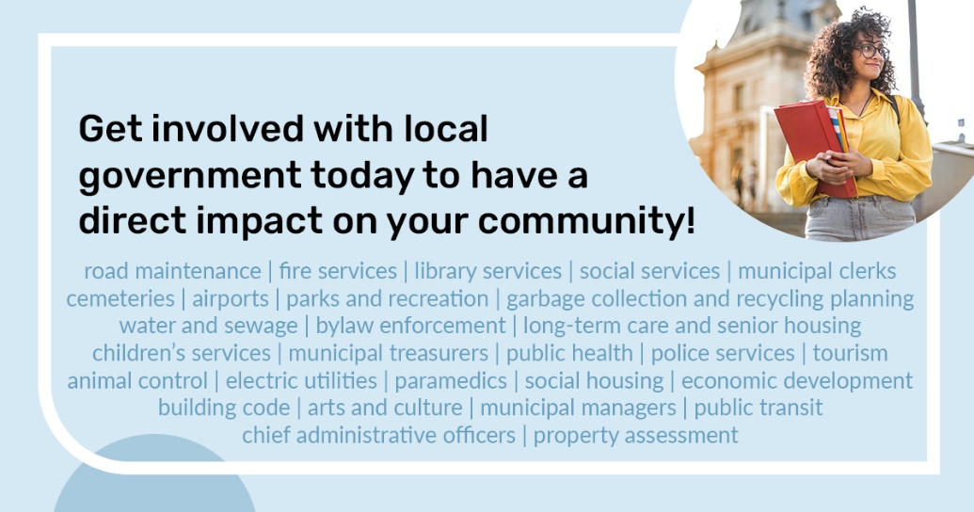

Sample Post #2:
#DYK: October 18-24, 2026 is Local Government Week! We are proud to serve our community by providing the programs and services that residents rely on daily. Thank you to our local government professionals who work hard to make life happen! #LocalGovWeek
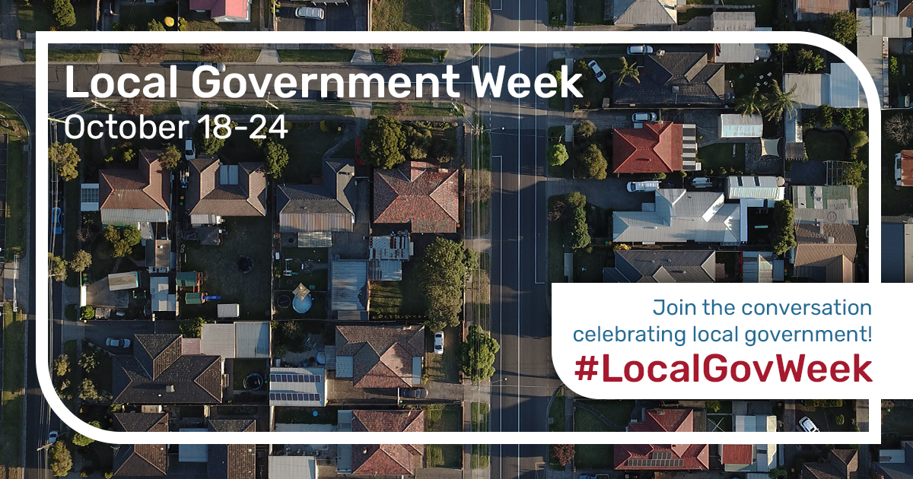

Sample Post #3:
If you are an innovator, a social entrepreneur, or someone who wants to make a difference, a career in local government may be the perfect opportunity! Get involved and see what local government can do for you! #LocalGovWeek
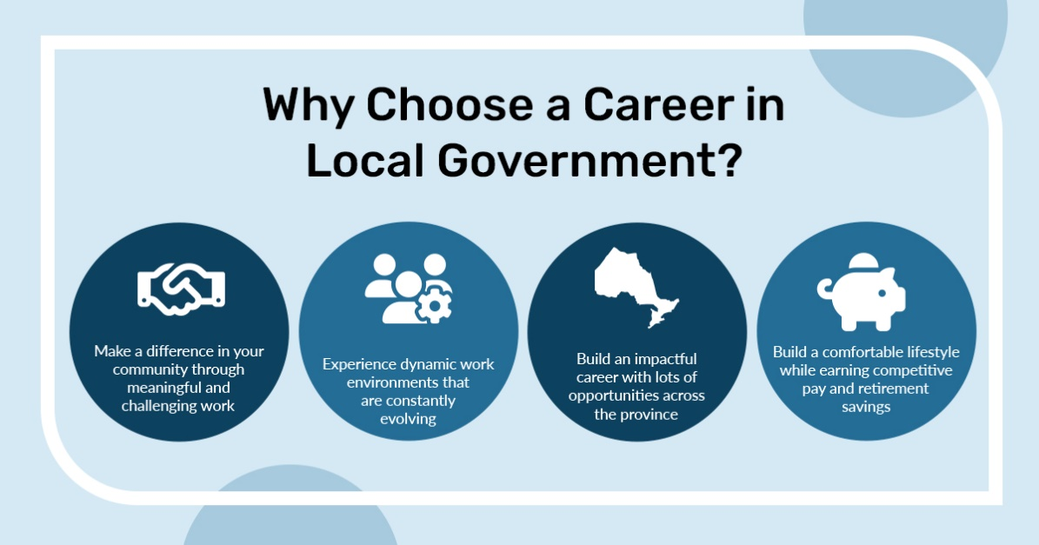

Sample Post #4:
Municipal clerks are more than minute-takers - they are leaders in governance, elections, records management, and more! Their work helps build trust between municipalities and the communities they serve.
Happy #LocalGovernmentWeek to the clerks who keep local government moving!
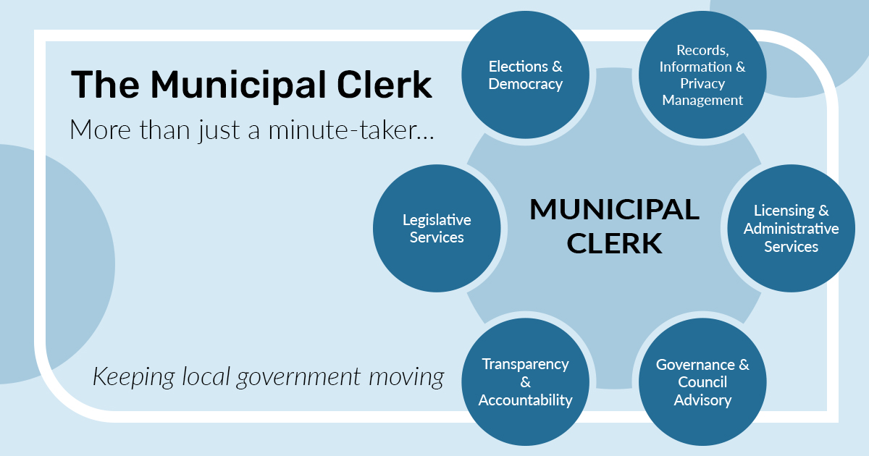

Sample Post #5:
Municipal treasurers do more than balance the books – each day they navigate the municipality’s current needs planning for tomorrow through budgeting, risk management, long-term strategy, and more!
Join us in celebrating #LocalGovernmentWeek with the treasurers that help build financially resilient communities!
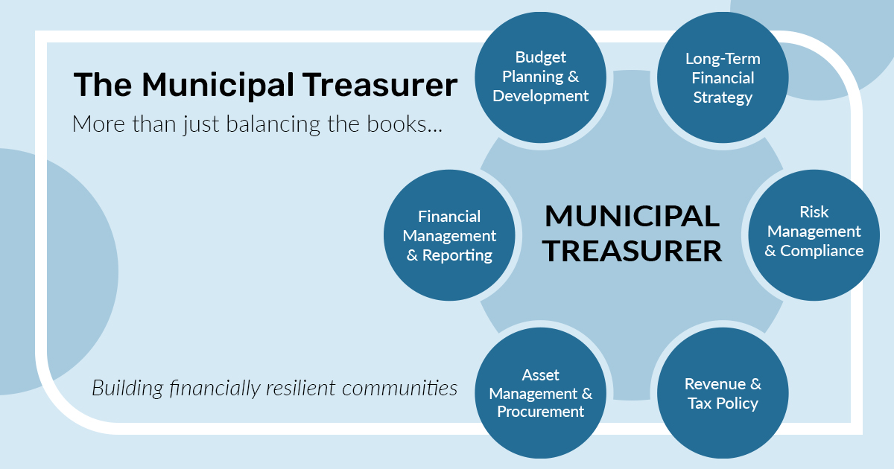

Sample Post #6:
Municipal managers do more than just manage people – they turn council's vision into action, lead organizational change, and help ensure residents receive the services they rely on every day.
Wishing a happy #LocalGovernmentWeek to municipal managers who are turning strategy into community impact!
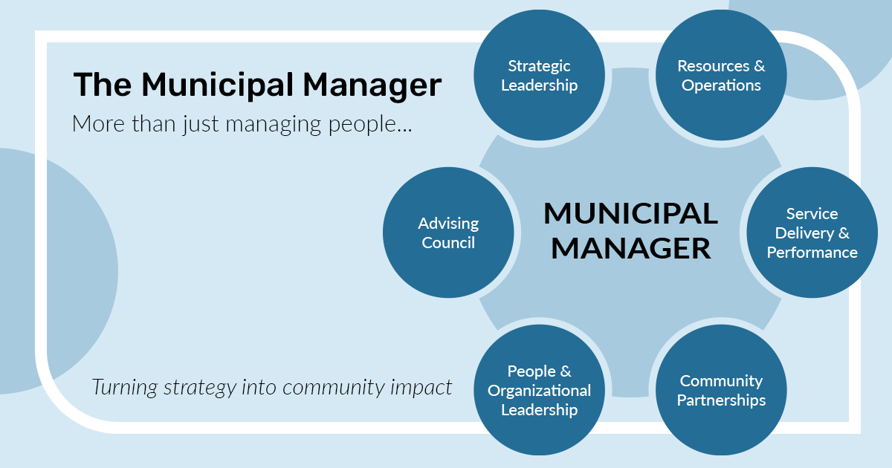
X (Twitter)
Sample Post #1:
During this Local Government Week (October 18-24), find out how you can get involved and explore future career opportunities in the sector. Visit [municipality website] to learn more. #LocalGovWeek
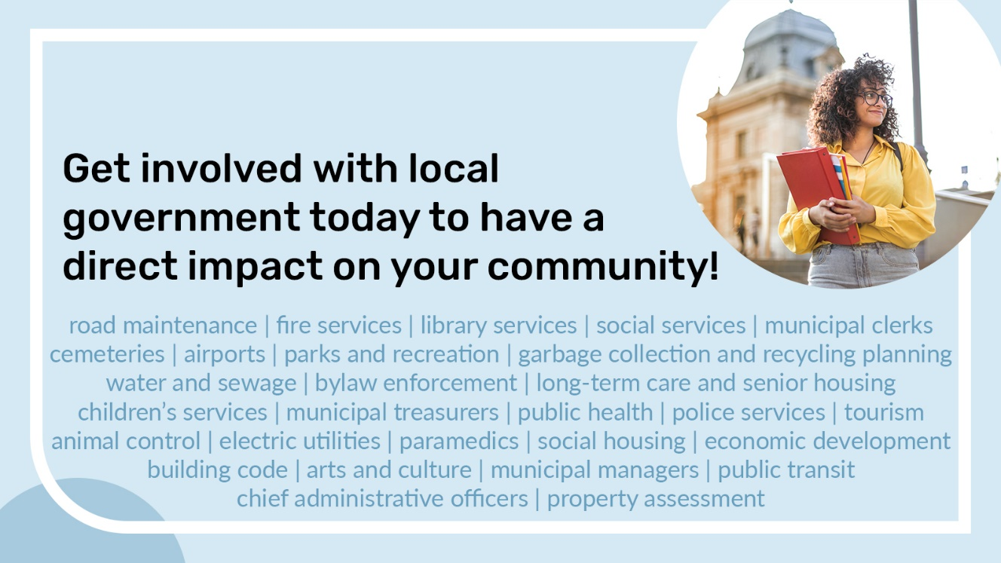

Sample Post #2:
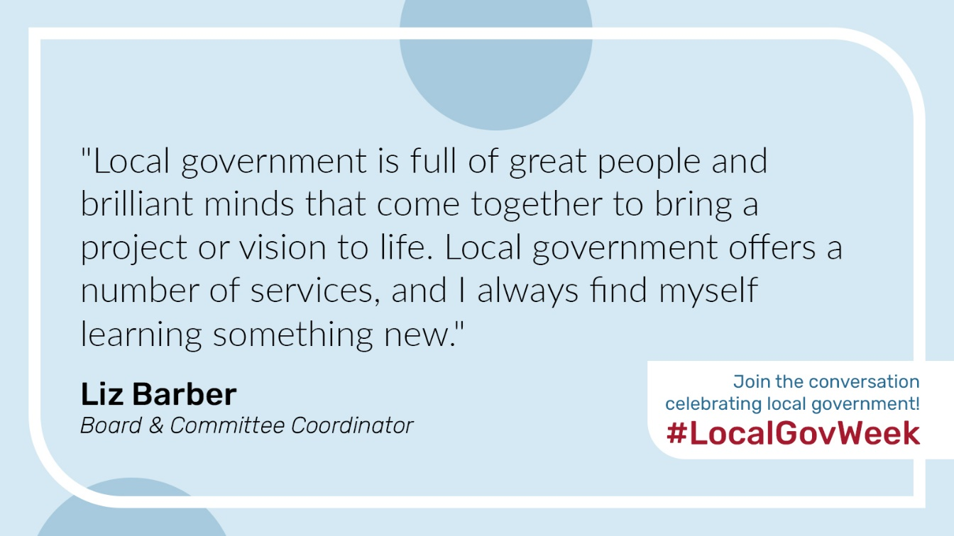
We are proud to participate in Local Government Week this October 18-24! Thank you to all local government professionals who work hard to make life happen! #LocalGovWeek

Sample Post #3:
Discover the valuable career opportunities that exist in local government. Visit [municipality website] to learn more about how you can get involved and make an impact in your community! #LocalGovWeek
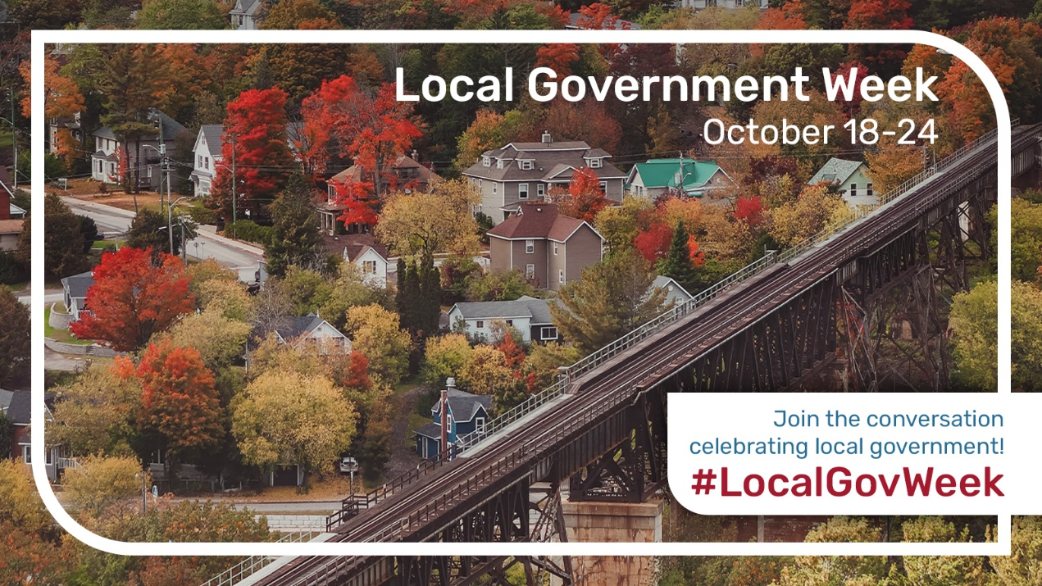

Sample Post #4:
Municipal clerks are more than minute-takers - they are leaders in governance, elections, records management, and more! Their work helps build trust between municipalities and the communities they serve.
Happy #LocalGovernmentWeek to the clerks who keep local government moving!
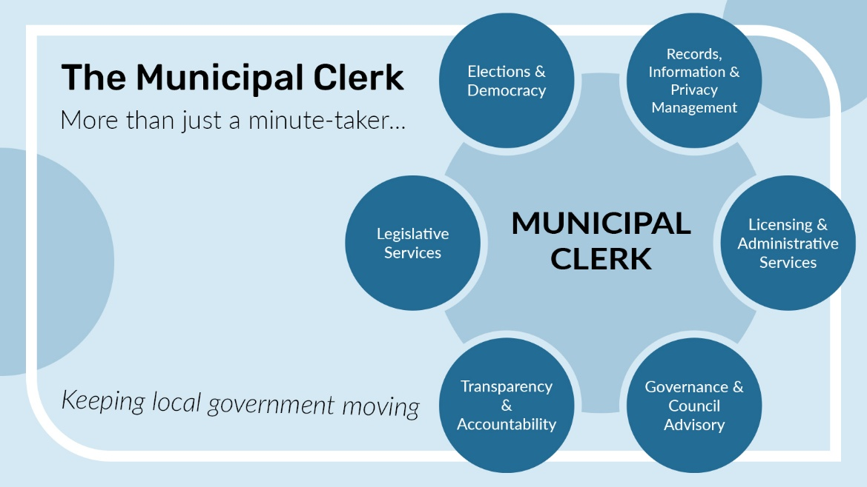

Sample Post #5:
Municipal treasurers do more than balance the books – each day they navigate the municipality’s current needs planning for tomorrow through budgeting, risk management, long-term strategy, and more!
Join us in celebrating #LocalGovernmentWeek with the treasurers that help build financially resilient communities!
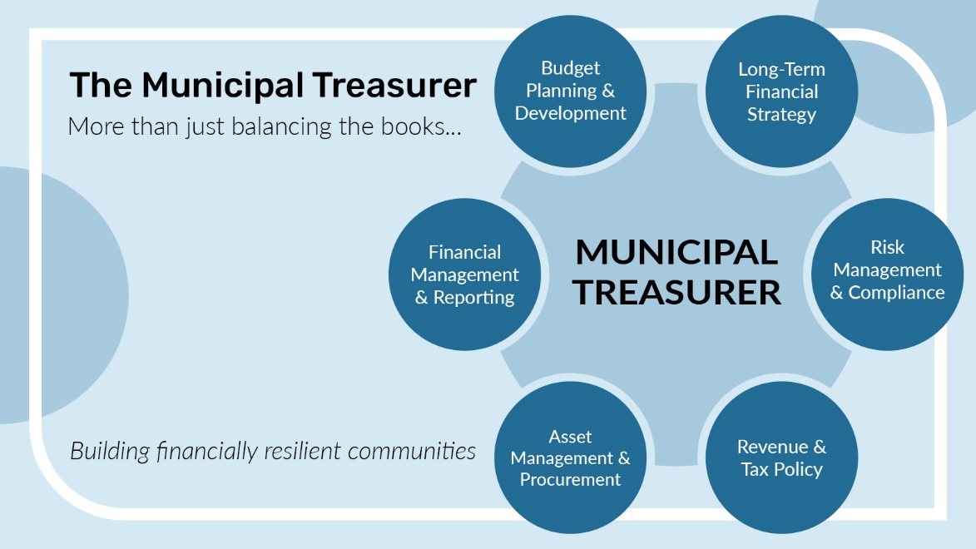

Sample Post #6:
Municipal managers do more than just manage people – they turn council's vision into action, lead organizational change, and help ensure residents receive the services they rely on every day.
Wishing a happy #LocalGovernmentWeek to municipal managers who are turning strategy into community impact!
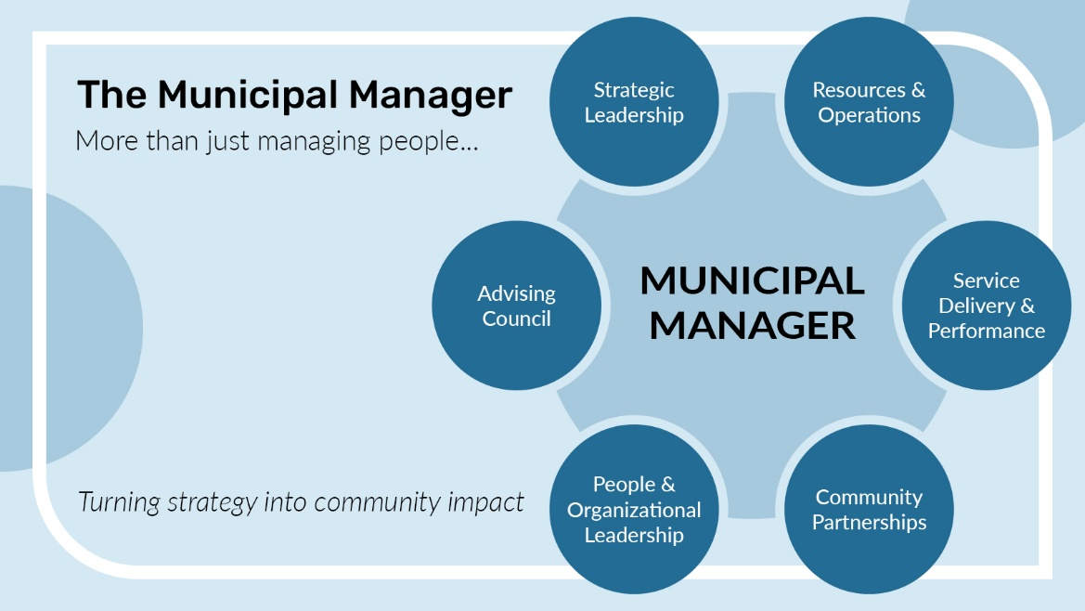

Instagram
Sample Post #1:
A career in local government can be extremely rewarding. Discover how you can make a difference by getting involved today – explore various career pathways and available opportunities by visiting our website careers page. #LocalGovWeek

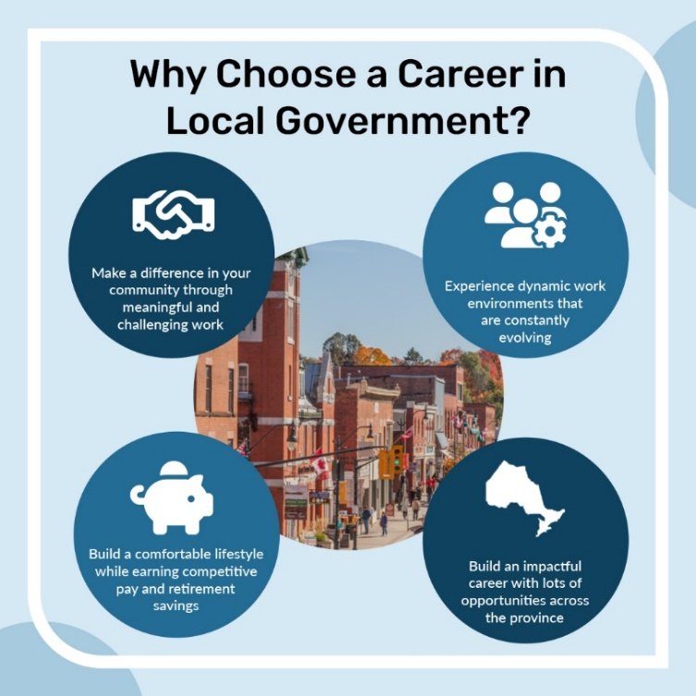

Sample Post #2:
[Municipality name] is happy to participate in Local Government Week taking place this October 18-24. From taking care of necessities like roads, waste, and water, to creating diverse arts, culture, and tourism experiences, to finding innovative solutions to tomorrow’s challenges, local government professionals are change-makers and community builders. Thank you to our local government professionals who work hard to make life happen! #LocalGovWeek
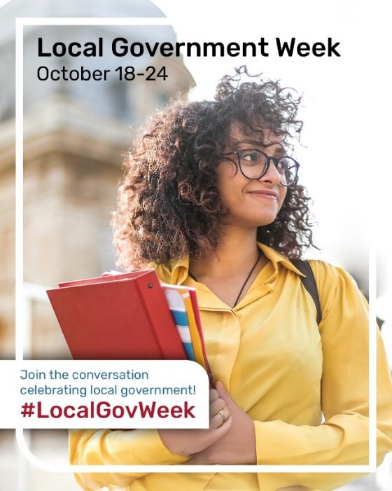

Sample Post #3:
#DYK: There are many ways you can get involved in local government. Visit our website to learn more about how you can make a direct impact on your community!
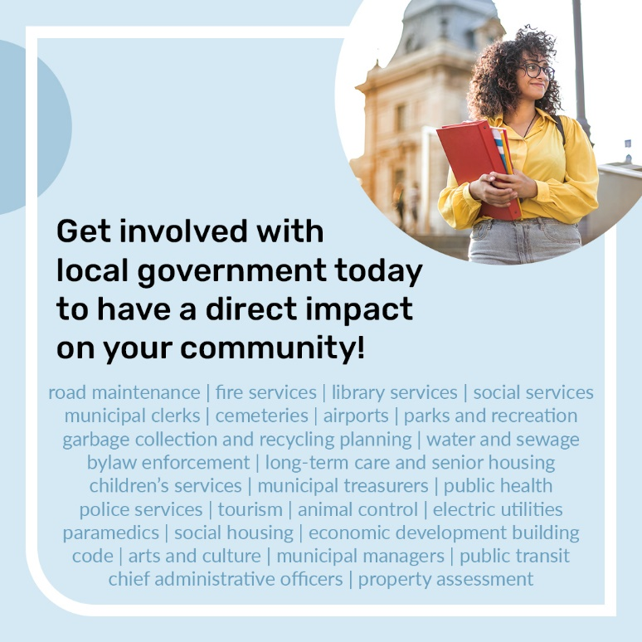

Sample Post #4:
Municipal clerks are more than minute-takers - they are leaders in governance, elections, records management, and more! Their work helps build trust between municipalities and the communities they serve.
Happy #LocalGovernmentWeek to the clerks who keep local government moving!
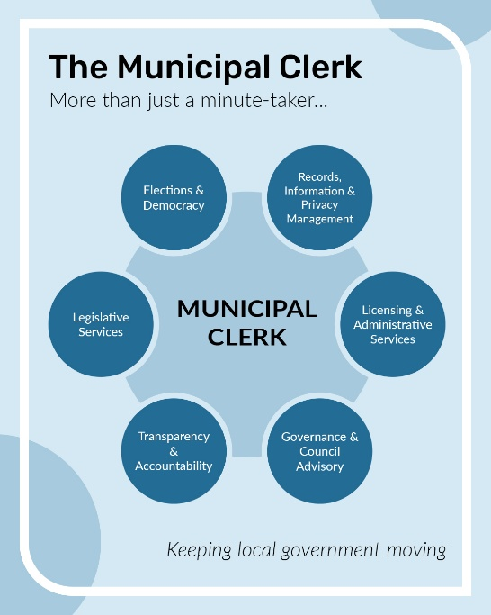

Sample Post #5:
Municipal treasurers do more than balance the books – each day they navigate the municipality’s current needs planning for tomorrow through budgeting, risk management, long-term strategy, and more!
Join us in celebrating #LocalGovernmentWeek with the treasurers that help build financially resilient communities!
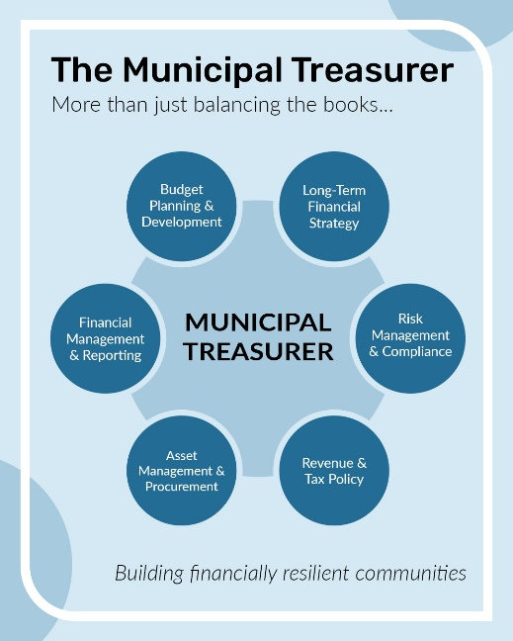
Sample Post #6:
Municipal managers do more than just manage people – they turn council's vision into action, lead organizational change, and help ensure residents receive the services they rely on every day.
Wishing a happy #LocalGovernmentWeek to municipal managers who are turning strategy into community impact!
